7th Grade Internet Based Assignments and Information
WEEK TWO: April 6-10
English Language Arts
- If you go to youtube.com, Mr. McCarthy will read the entire Divergent novel to you by chapters. Just type in DIVERGENT AUDIOBOOK, and it should take you to his readings. You can also access the audio through audible.com if you have an account.
- Noredink.com- Sign in under your account and you should be able to practice anything you want, but pay special attention to skills dealing with combining sentences, FANBOYS, THAMOs, SWABIs, colons, and semicolons.
- Go to www.mpisd.net and download the 7th grade packet for week two. Read the passage and complete the activities. Please email your work to your teacher when completed. If you do not want to print the packet, just read it on the screen and type your answers in a document (something like word or google docs).

Social Studies
Texas Indian Cultures
Directions: If you are using your device instead of paper copies… you will need to spend some time on EACH link.
- Indian Tribes in Texas- https://quizizz.com/join?gc=486668
- Indians Tribes- https://www.purposegames.com/game/ms-ms-texas-indian-tribes-review-game
- US Native American Tribes Game- https://online.seterra.com/en/vgp/3291
- Texas Native American Tribes Review Video- https://www.youtube.com/watch?v=5qbW02F8tV0
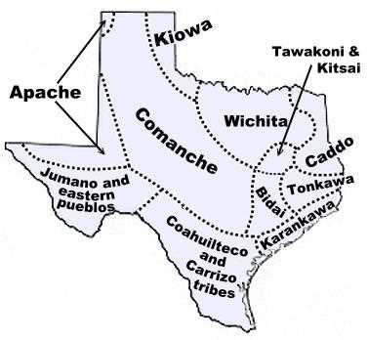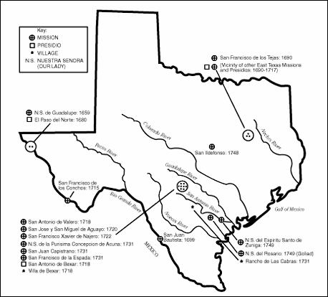

- Natural Texas and It’s People Review Quizizz https://quizizz.com/join/quiz/5dd7e7b91f9a69001b20f552/start

Pre-Algebra
- Percent of a Number
https://mathantics.com/lesson/finding-a-percent-of-a-number
- Finding the Total when you know the Part
https://mathantics.com/lesson/percents-missing-total
- What Percent is it?
https://mathantics.com/lesson/what-percent-is-it

Math
Solving Equations
https://www.youtube.com/watch?v=LDIiYKYvvdA

Science
We hope everyone is staying safe during this time and miss all of you. We currently have your work available as long as you log in under your stu.mpisd.net account in the following google drive link:
https://drive.google.com/drive/folders/1-RdUw5ZLb0T23u3J1YgwoGh4JorMnlSw?usp=sharing
Using this link, there are 4 weeks of science work currently uploaded. Please begin week 1 on March 30th and work from there. Record your answers for each question on a google doc or on notebook paper that you will keep up with.

Study Island is also a resource that may be used. Students know logins and passwords, if they have forgotten please contact the teacher via email.
studyisland.com

Elective Online Assignments
Health:
Lesson: Watch-
https://www.youtube.com/watch?v=-J1hmmy1OB4
Assignment:
https://quizizz.com/admin/quiz/57846046a30a491f6bab6131/my-plate-healthy-eating-quiz
-select “practice”

Art:
https://www.pbslearningmedia.org/collection/elements-of-art/#.XoIDnYhKjb4
https://www.youtube.com/watch?v=HZPIbqDFLI8
Business Marketing
http://learn.aeseducation.com/ Remember your login name is ID@student.mpisd.net and the password you created. If for some reason you cannot login or forgot your password please email me jjones2@mpisd.net and I can reset both of them if needed. I know not all of our students are not finished with Personal Financial Literacy module so it is currently still open.
Outdoor adventure
https://tpwd.texas.gov/huntwild/wild/species/lmb/
https://tpwd.texas.gov/huntwild/wild/species/ccf/
https://tpwd.texas.gov/huntwild/wild/species/crappie/
https://tpwd.texas.gov/huntwild/wild/species/wcp/

https://www.youtube.com/watch?v=NThAEFAwj1A
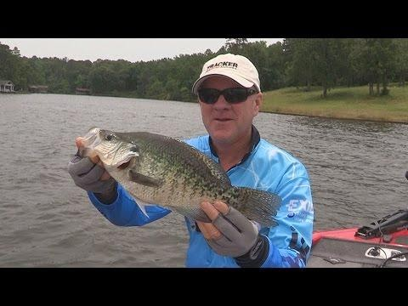 | FOX Sports Outdoors PREVIEW #13 - 2015 Cypress Springs Texas Crappie Fishing - YouTube  www.youtube.com  Take a quick look at some great crappie action from Cypress Springs Lake in east Texas. See the full episode Thursday night and this weekend on SportSouth Ne...
PE
Directions can be found in the complete packet online.
ESL
1st Period ESL ttps://quizlet.com/join/66zF3qjmz
Download the Duolingo app and join your class period. I can see you logs in and the activities that you do and for how long you stay in the app.

1st period ESL https://www.duolingo.com/o/dqzgkz or use this classroom code: DQZGKZ

Dance
Learn any style of dance routine from YouTube or TikTok) or create your own.
Spanish
3rd Period Spanish https://quizlet.com/join/xgu7qz8ER
7th period Spanish https://quizlet.com/join/rrZnr4ge3
8th Period Spanish https://quizlet.com/join/yKFtzRVvy
Download the Duolingo app and join your class period. I can see you logs in and the activities that you do and for how long you stay in the app.
3rd Period https://www.duolingo.com/o/qdpyxt or use this classroom code: QDPYXT
7th period https://www.duolingo.com/o/zpqqhu or use this classroom code: ZPQQHU
8th period https://www.duolingo.com/o/evbjeg or use this classroom code: EVBJEG

STEM
The link to the Google Classroom is:
https://classroom.google.com/u/0/c/NDg2OTI2NDA1ODNa/a/NTc3ODQ3MDU5ODha/details
Theatre Production class
The radio play the Maltese Falcon can be found on the link below, we will have a zoom video chat and study it together so you will have to load the zoom app on your phone and I will text you the times and meeting code. Please read the play before Wednesday.

http://genericradio.com/series/academyawardtheater

Theatre Arts classes
- Read a children’s story either online or from a book at home.
- After reading the book I what you to design the set on paper draw and color or use a picture collage to show your vision of how the stage should look for the play version of that story. (assignment for the week of Mar. 30-April 4, 2020).
- Next write a four-scene skit that adapts the story in script form. You may have a narrator plus the characters. Please follow the format we have used in class for script writing. Fill free to change the setting, and time period of the story. (assignment for April 6-10, 2020).

